CS 340 7-2 Project Two Submission/Screen Shots

README File

Screenshots showing the following:

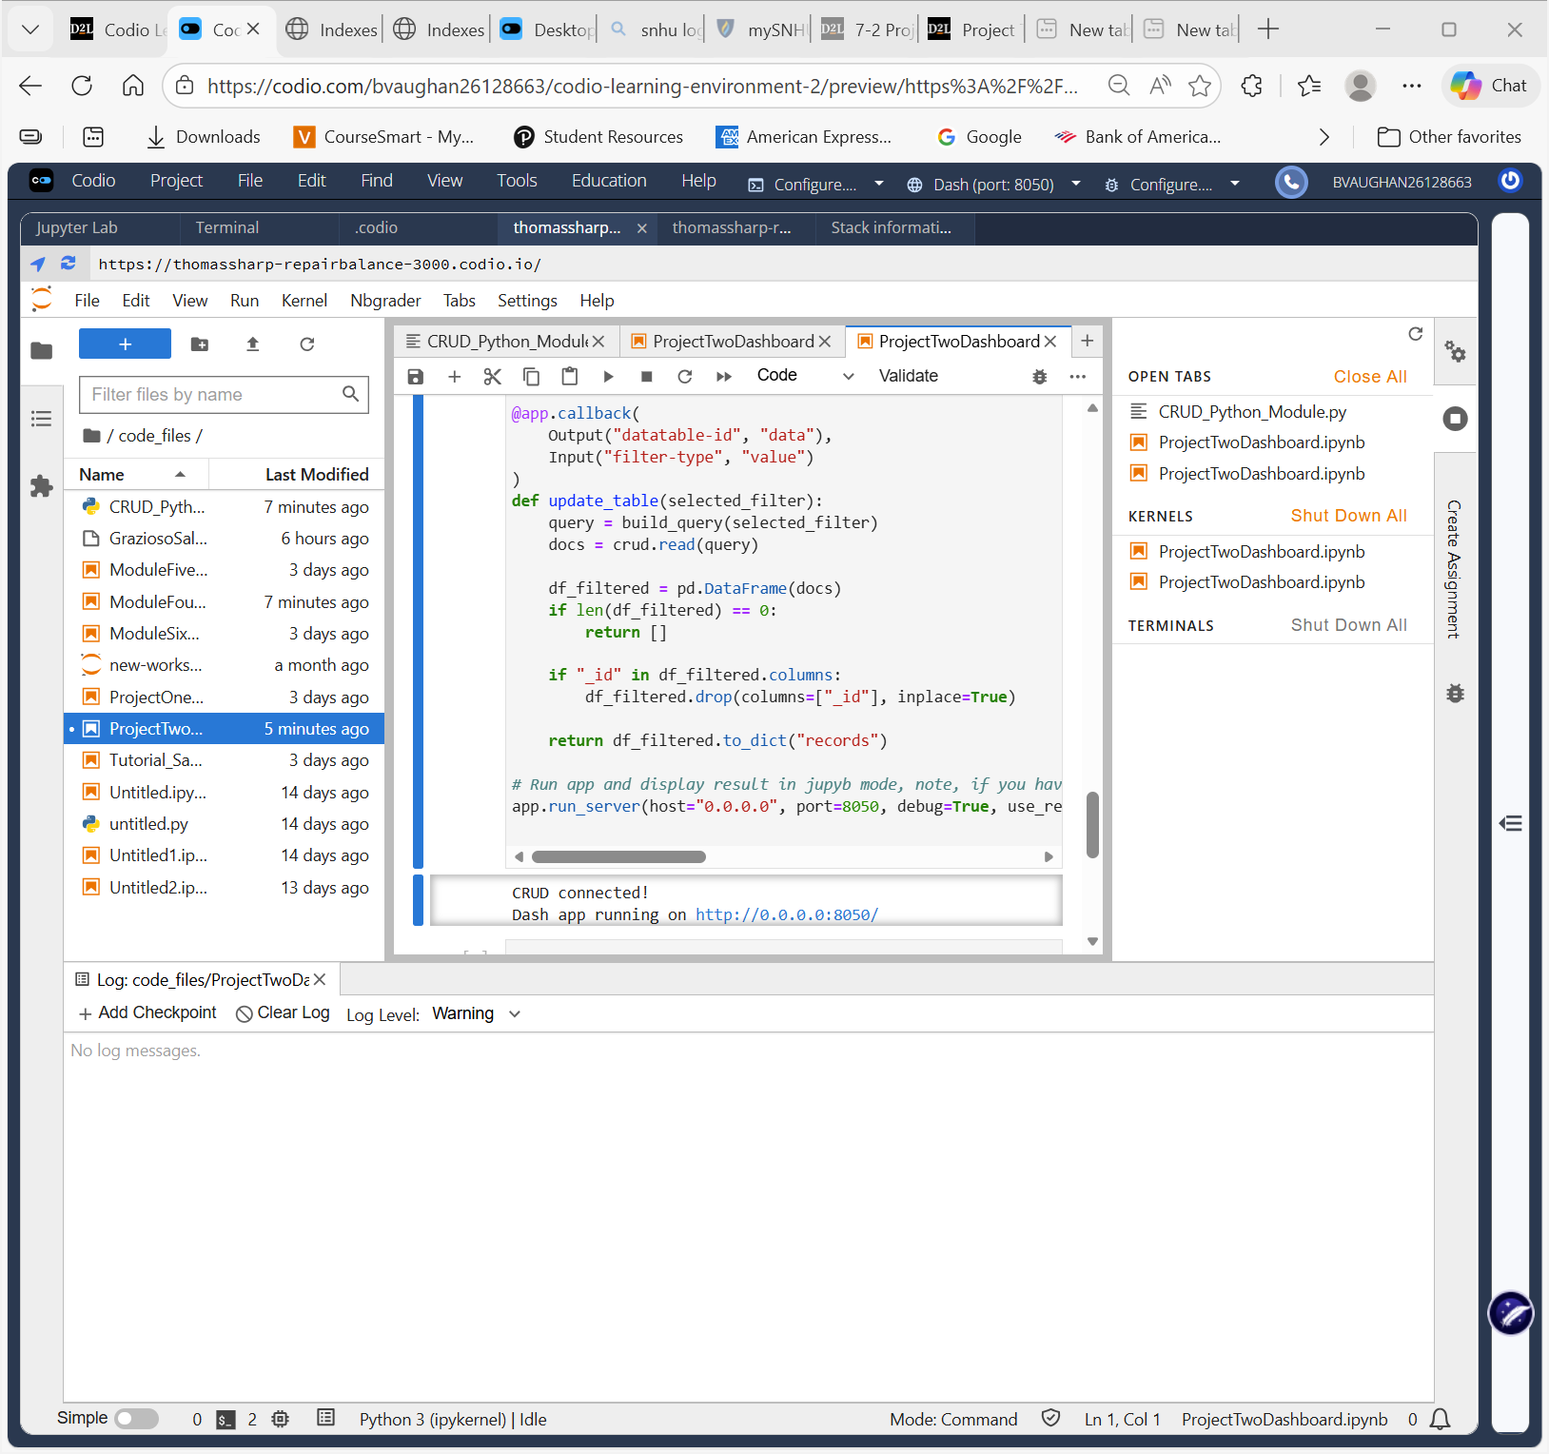

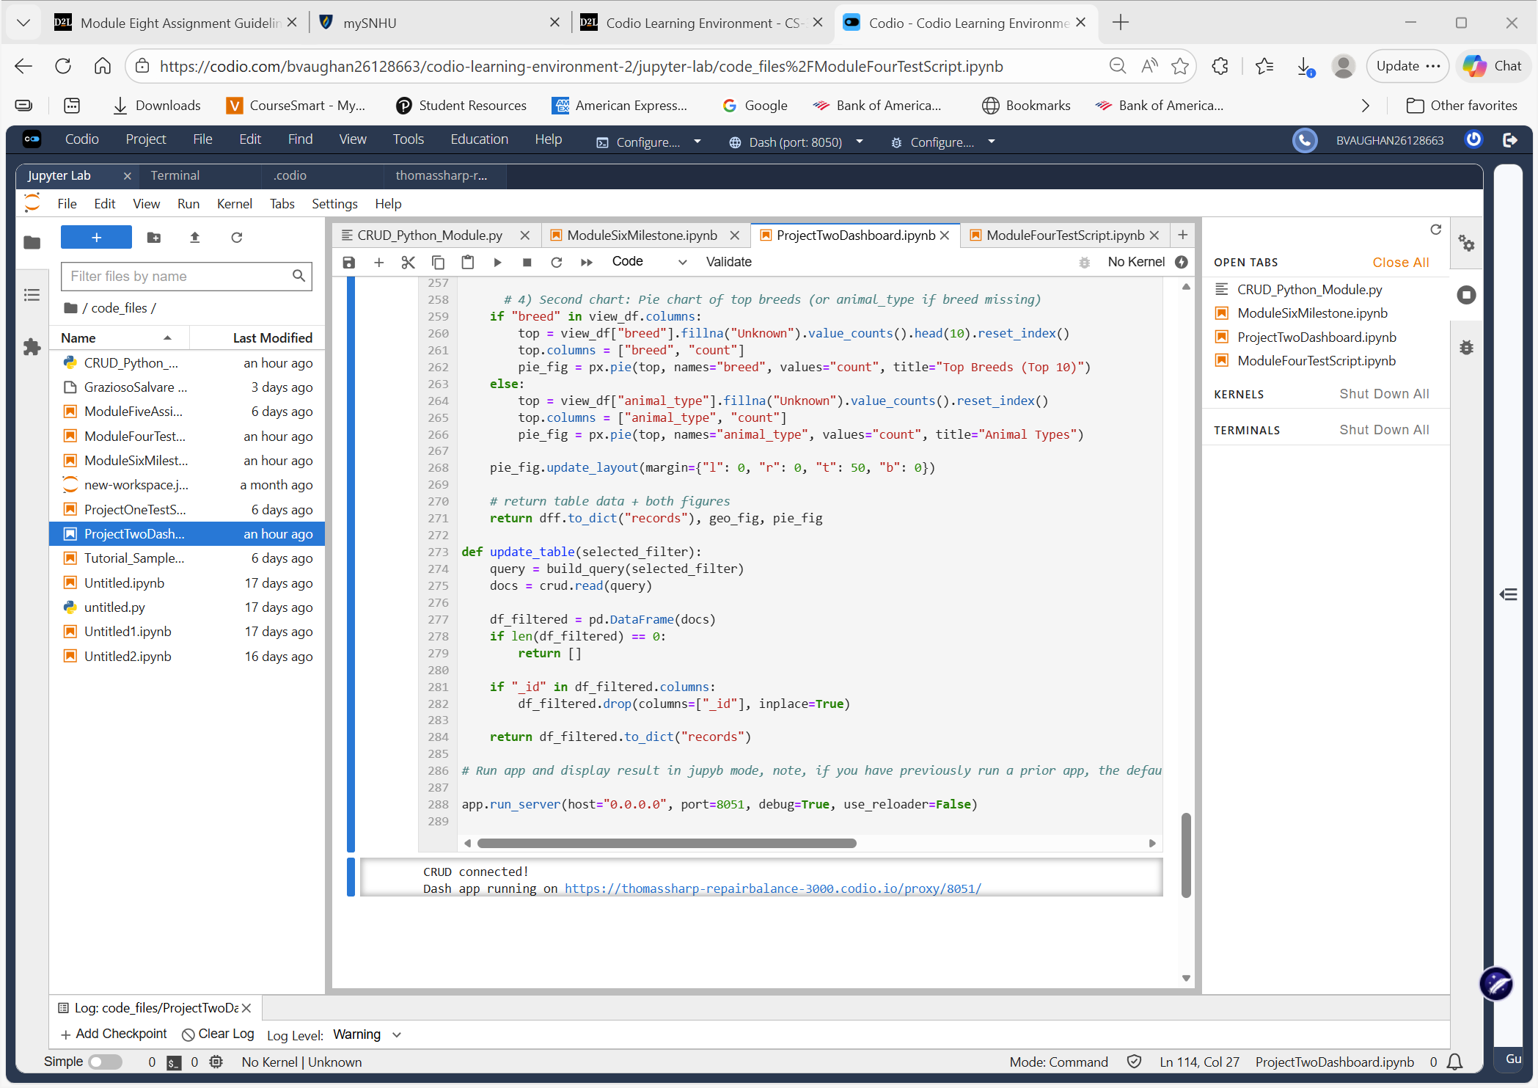
- The starting state of your dashboard, which should include your widgets for the interactive options to filter data (such as radio items or drop-downs), the interactive data table, and the charts.
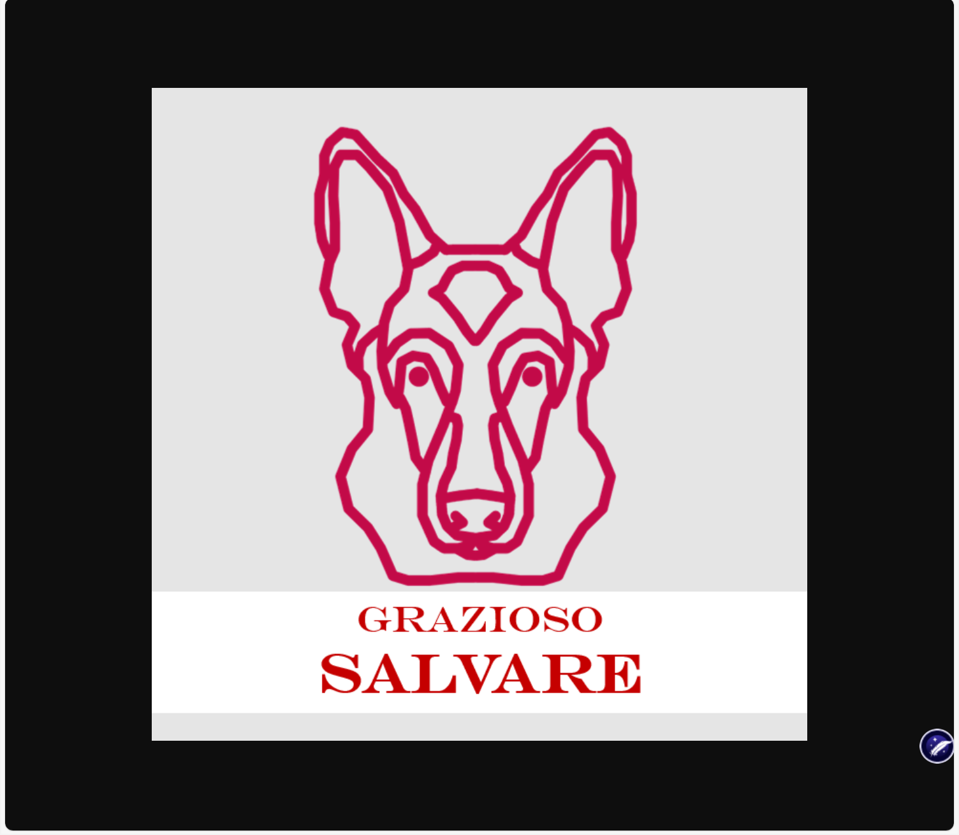
Grazioso Salvare Logo
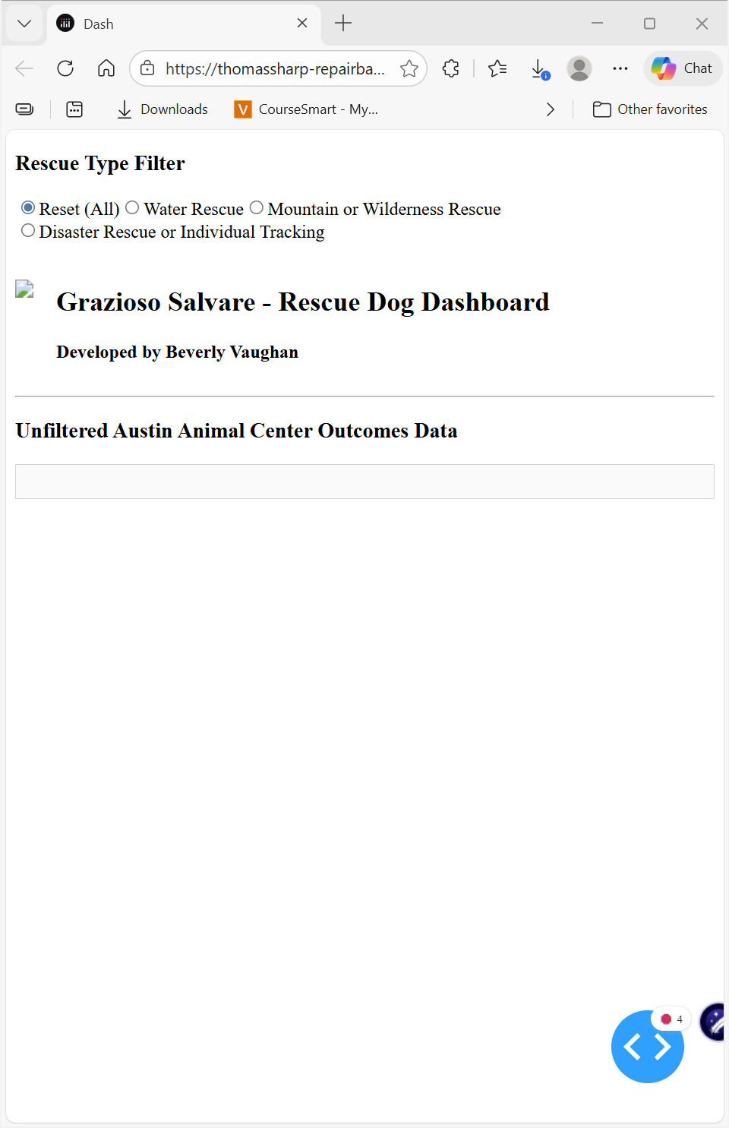
•Logo ✅
• “Developed by Beverly Vaughan” ✅
• The unfiltered table ✅
• Sorting/filtering/pagination
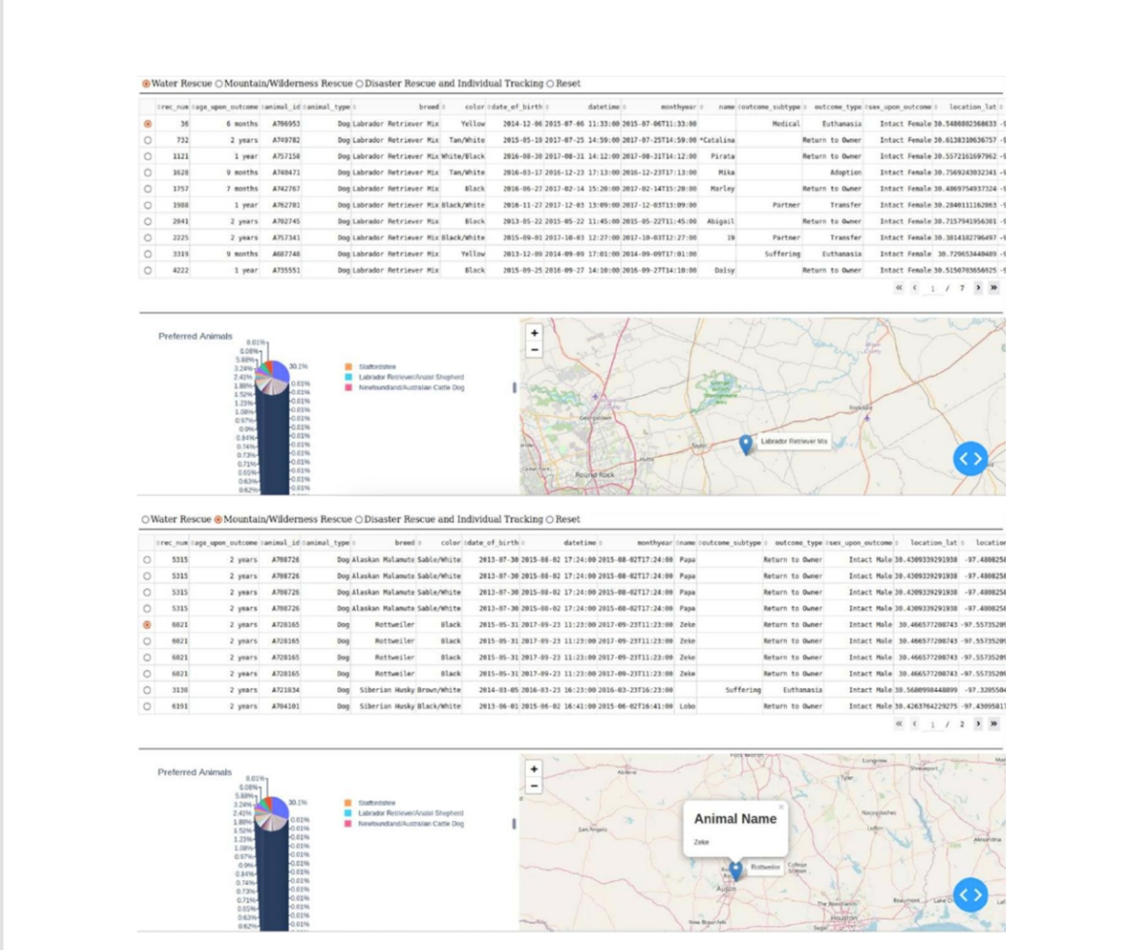
Charts that display data:
- Interactive Data Table
- Geolocation Map
- Breed Distribution Chart
ReadMe file: Documents the project and provides instructions for reproducing it.

Project Purpose
This project delivers a full-stack client/server dashboard application for Grazioso Salvare, an international rescue dog training organization. The system enables users to identify and categorize dogs suitable for specific rescue training types using data from the Austin Animal Center Outcomes dataset stored in MongoDB.
The dashboard integrates:
- MongoDB (Model)
- Dash Web Application (View)
- Python CRUD Module (Controller)
This architecture follows the MVC design pattern.
Required Functionality Demonstrated
The completed dashboard includes:
Interactive Filtering Options
Users can filter dogs by:
- Water Rescue
- Mountain or Wilderness Rescue
- Disaster Rescue or Individual Tracking
- Reset (Unfiltered View)
Each filter dynamically updates:
- Interactive Data Table
- Geolocation Map
- Breed Distribution Chart
Tools Used and Rationale
MongoDB (Model)
MongoDB was selected because:
- It stores data in flexible JSON-like documents.
- It integrates seamlessly with Python via PyMongo.
- It allows efficient filtering using structured dictionary queries.
- It supports scalable NoSQL storage ideal for semi-structured shelter data.
MongoDB enables:
- Flexible schema
- Fast document retrieval
- Efficient filtering by breed, sex, and age
PyMongo
Used to:
- Authenticate database users
- Execute filtered queries
- Retrieve documents into Python

Dash Framework (View + Controller)
Dash provides:
- Interactive UI components
- Callback-driven dynamic updates
- DataTable functionality
- Integration with Plotly graphs
Dash allows the entire application (frontend and backend) to be built using Python without requiring JavaScript.
Plotly Express
Used to create:
- Geolocation map displaying dog locations
- Secondary visualization (breed distribution chart
Pandas
Used to:
- Convert MongoDB query results to DataFrames
- Clean and format data
- Prepare chart-ready datasets

Project Completion Steps
- Imported Austin Animal Center dataset into MongoDB.
- Created MongoDB user with authentication.
- Developed CRUD module for Create and Read operations.
- Connected dashboard to MongoDB using authenticated credentials.
- Built interactive DataTable displaying unfiltered data.
- Implemented MongoDB queries based on rescue type requirements:
  - Breed filters
  - Preferred sex
  - Age ranges in weeks
- Created Dash callbacks linking:
  - Filter selection
  - DataTable updates
  - Map updates
  - Chart updates
- Integrated Grazioso Salvare branding.
- Conducted full functionality testing.
- Captured screenshot evidence.

Challenges and Resolutions

MongoDB Authentication Errors
Resolved by properly formatting connection URI and specifying authSource=admin.
Data Not Appearing in Table
Resolved by:
- Removing MongoDB _id field
- Matching filter string values exactly
- Confirming correct breed list formatting
How to Reproduce This Project
- Install Python 3.11
- Install required packages:
pip install dash pymongo pandas plotly
- Install MongoDB locally.
- Create database named aac.
- Import Austin Animal Center dataset.
- Create MongoDB user:
  - Username: aacuser
  - Password: ab@one
  - Role: readWrite on database aac
  - Authentication database: admin
- Place files in same directory:
  - CRUD_Python_Module.py
  - ProjectTwoDashboard.ipynb
  - Logo image
- Run Jupyter Notebook.
- Execute all cells.
Competency Demonstration
This project demonstrates mastery of:
✔ Applying database systems concepts in a client/server application
✔ Developing client-side code that interfaces with MongoDB
✔ Implementing MVC architecture
✔ Creating dynamic data visualizations
✔ Writing maintainable, documented code

What Makes This Project Stand Out
- Clean MVC architecture
- Fully interactive dashboard
- Real-time database filtering
- Dynamic geolocation visualization
- Industry-standard documentation
- Open-source ready

References
Austin Animal Center (2020). Austin Animal Center Outcomes Dataset.
Dash Documentation – https://dash.plotly.com
MongoDB Documentation – https://www.mongodb.com/docs/
PyMongo Documentation – https://pymongo.readthedocs.io/

